Node Failure in MANET

Nodes in a network can fail due to a variety of reasons e.g., broken node hardware, a broken network, software bugs etc. First Node failure and half node failure time will have direct impact on the Network lifetime. To analyse the reliability of a MANET network we can fail nodes at a specific time and analyse its impact over the Network Performance.

We use an input file NodeFailure.txt which contains the Node Id’s and the respective time (in micro seconds) at which they will fail.

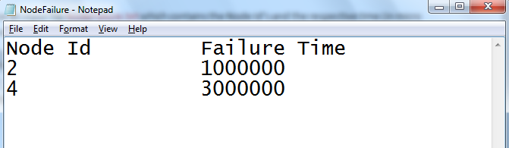

# Steps to run Node Failure Code in NetSim:

1. Open the Simulation - Node Failure folder and double click on the NetSim.sln file to open the project in visual studio.
2. Right click on the DSR project in the solution explorer and select Rebuild.

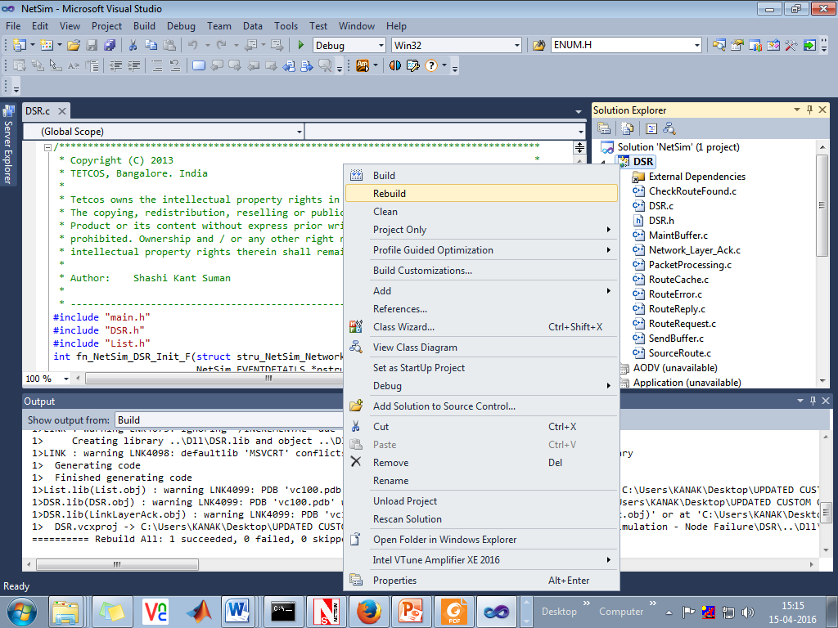

1. Now copy the newly built libDSR.dll file from the DLL folder that is inside the Simulation - Node Failure directory.

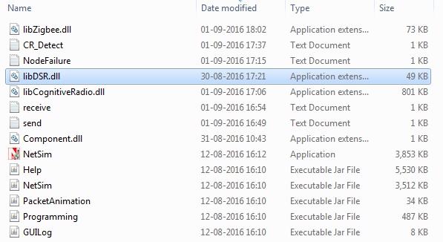

1. Replace the DLL in the bin folder inside the NetSim installation directory, after renaming the original libDSR.dll file.
2. 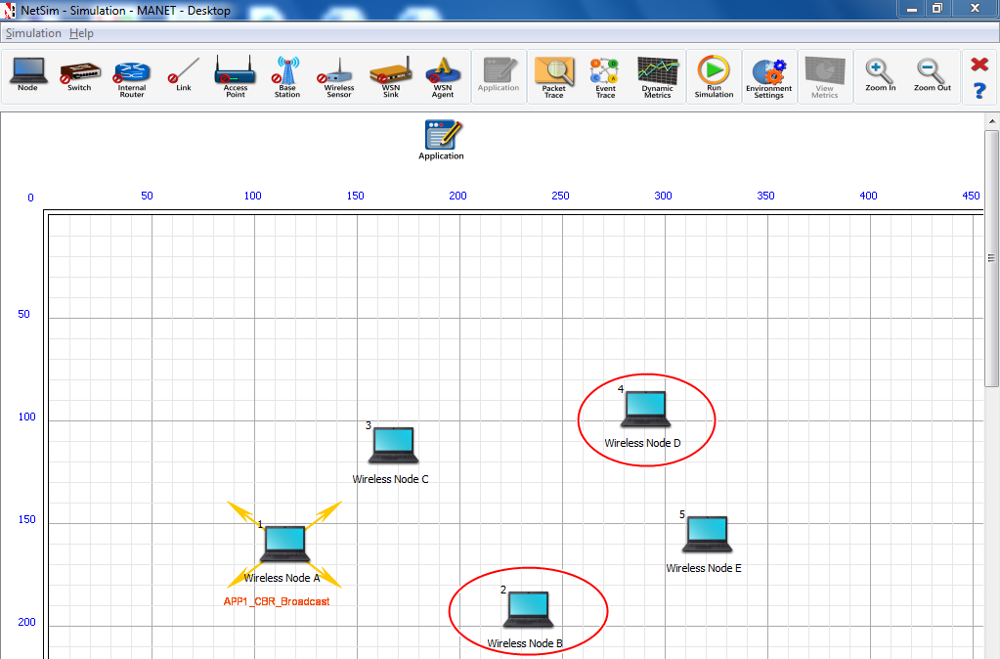Create a network scenario in MANET and configure traffic.
3. Create a text file named NodeFailure.txt containing the details of the nodes you want to fail and the respective time.
4. Run the Simulation.
5. View packet animation. You will note that once a node fails it stops forwarding packets it receives.